|  |  |  |  |  |  |  |
| --- | --- | --- | --- | --- | --- | --- |
|  |  | Source Data Set | | Target Data Set | | |
|  | n | Train Size (T) | Valid Size (V) | k | Train Size (T2) | Test Size (V2) |
| Tiny ImageNet | {5,10,50} | 350n | 200n | / | / | / |
| Aptos | {5} | / | / | {1,10,50,100,300} | kn | n(300-k) |

1. n=5, k=10

Task1 Training:

* Accuracy

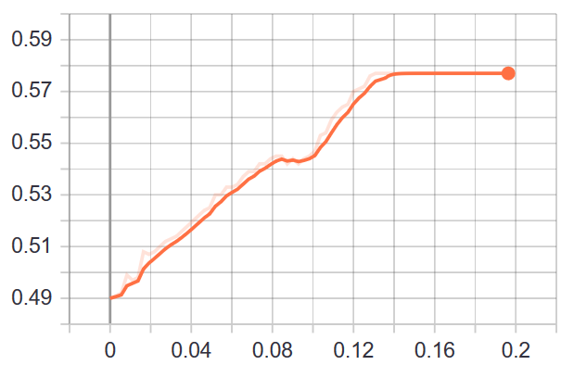

* Loss

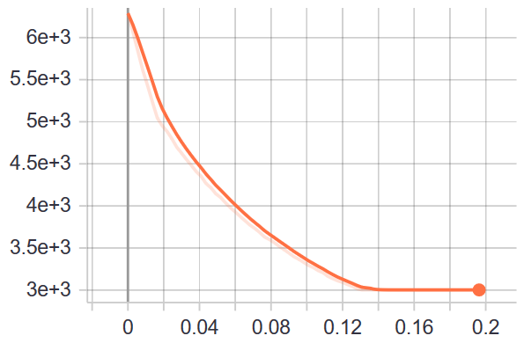

Task2 Training (Adaption):

* Accuracy

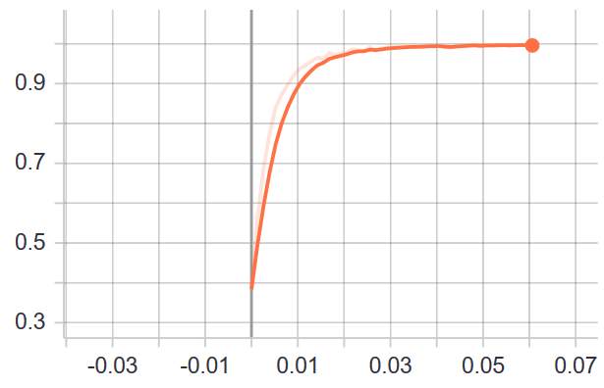

* Loss

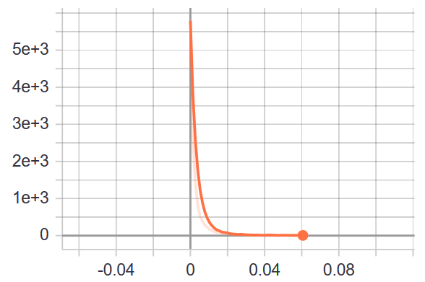

2.